**Meeting 09/08/2016**

**Agenda:**

* OGA version of the combined Scope (Nelya)
* User-friendly interface for active hyperlinks
* Creation of the Revision form in FB and promotion of the Revision module
* Issues related to navigation

Contents

**User-friendly interface for active hyperlinks** 2

**Creation of the Revision form in FB and promotion of the Revision module** 8

**Issues related to navigation:** 12

## **User-friendly interface for active hyperlinks**

**Good news:**

* Currently users add url to a question using “Learn more” field in Add/Edit Question screen in Form Builder. We can embed a WYSIWYG editor instead of text area for "learn more" field. Something like at <http://jwysiwyg.github.io/jwysiwyg/help/examples/01-basic.html>; we can control available formatting, leaving only basic text formats (bold, bullets, links, etc.)
* We can make sure that active link in Form Builder will stay active when passed to GreenSheets

From this: 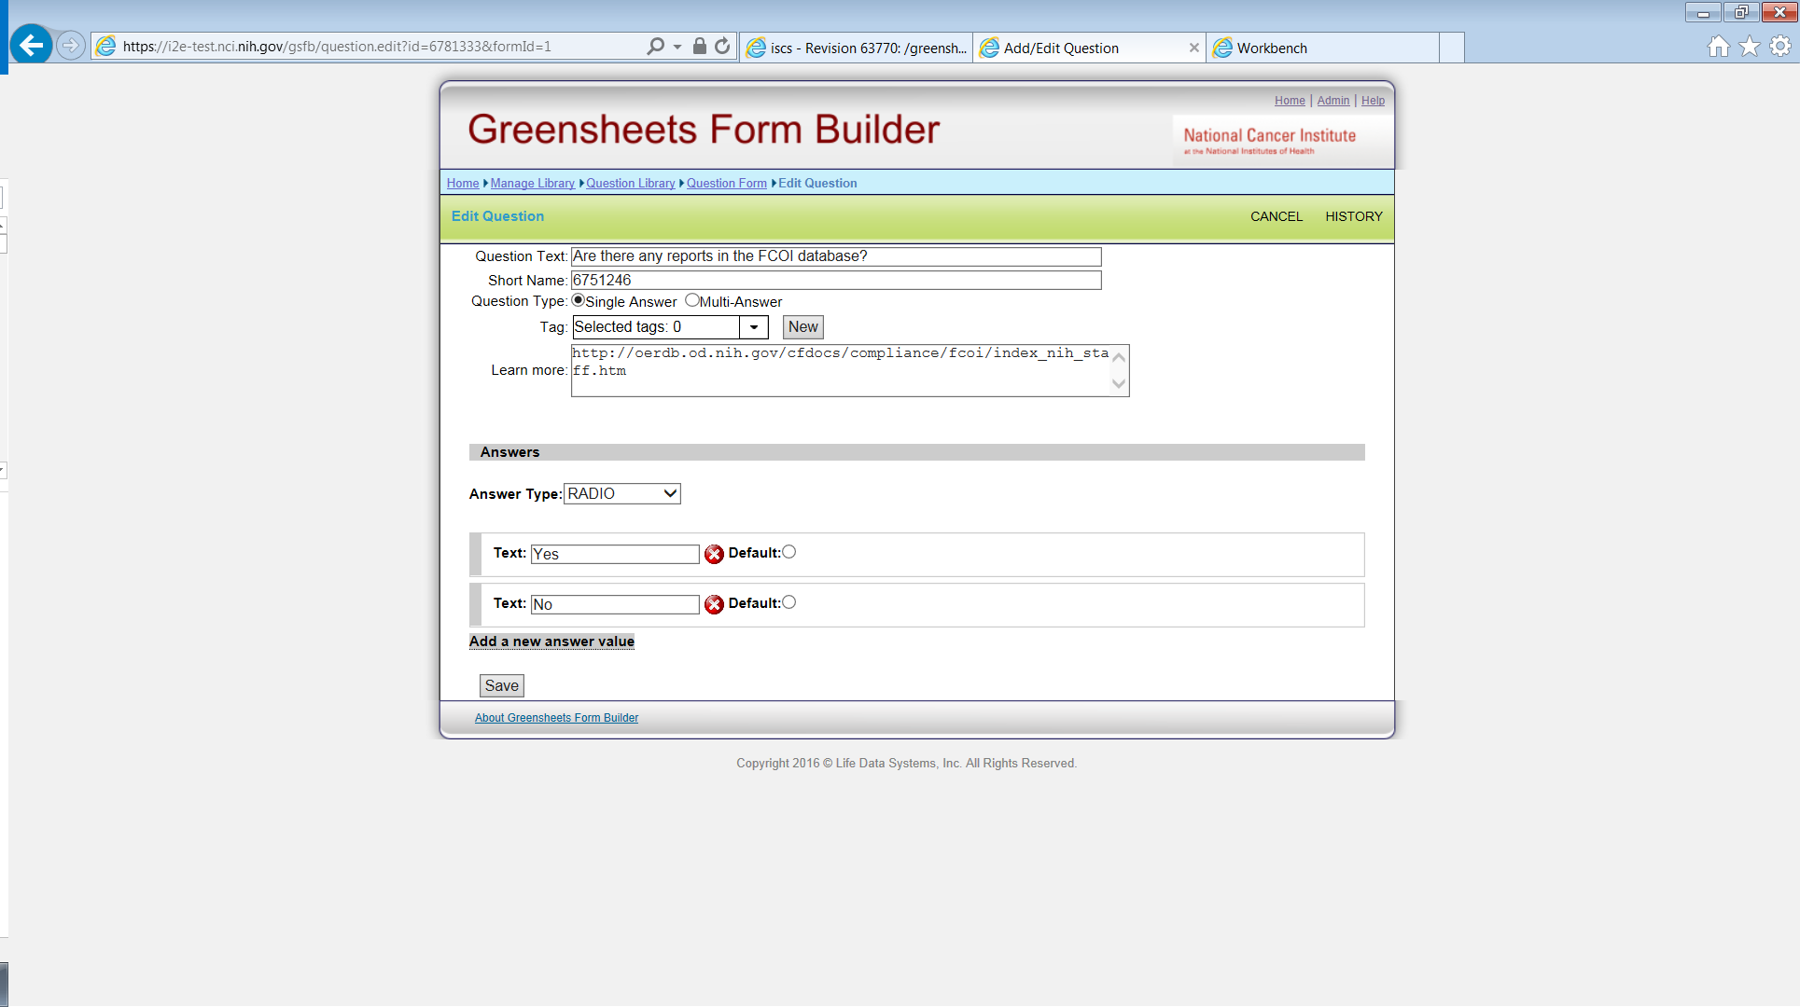

To this: 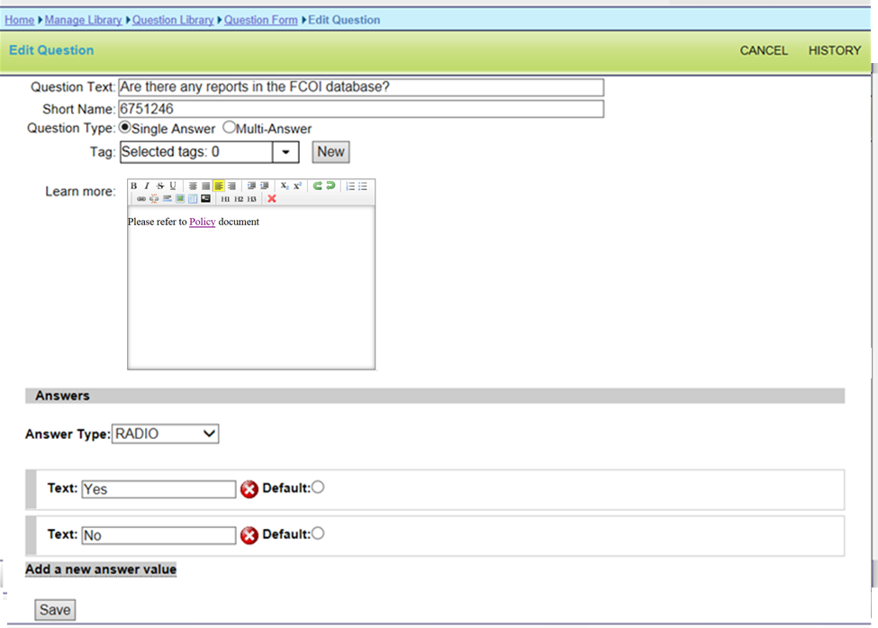

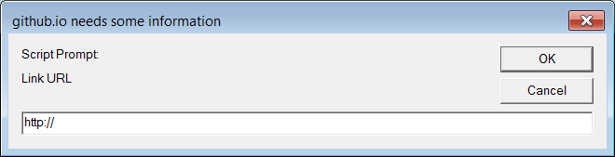

**Question:** To propose the rest of related modifications, CBIIT needs to understand what is the business flow for adding/modifying active hyperlinks? E.g.:

* 1. **Per form:** Are users going to open the module => open each form => find the question within the form that has URL => modify one form at a time and redeploy one module at a time? The limitation for this method is that new content will not get propagated to all other forms where this question is used (even if this question is linked to the libraries). *If this workflow will be used, we need to add editor to the “learn more’ field for question* ***in the form***.

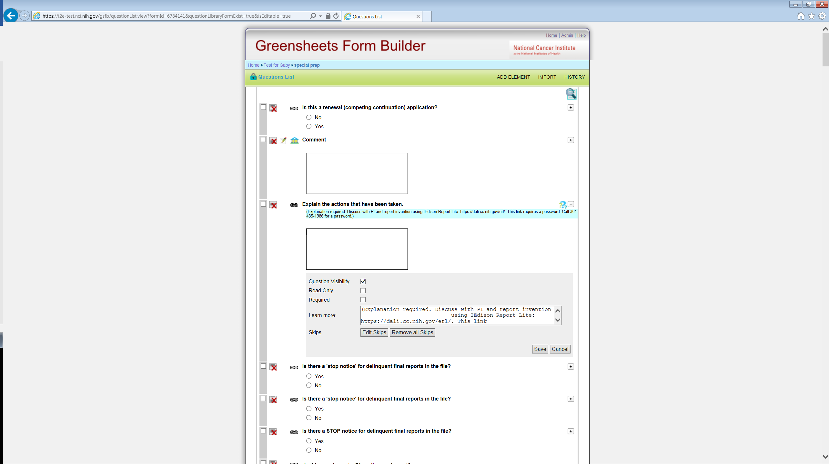

or

* 1. **Per section:** Do users want to open the question in the section library, have information about all forms/modules/type/mechs where this section is used => add/modify hyperlink for the question in the section => it will update all forms => redeploy all affected forms/modules? *In this case we, probably, will need to modify the search for the questions in the section (include keywords form “Learn More” field), provide better indication of usage on this* ***section*** *page (in which forms/modules/type/mechs this section is used), add editor to the “learn more’ field for question in the section, and add extra validations.*

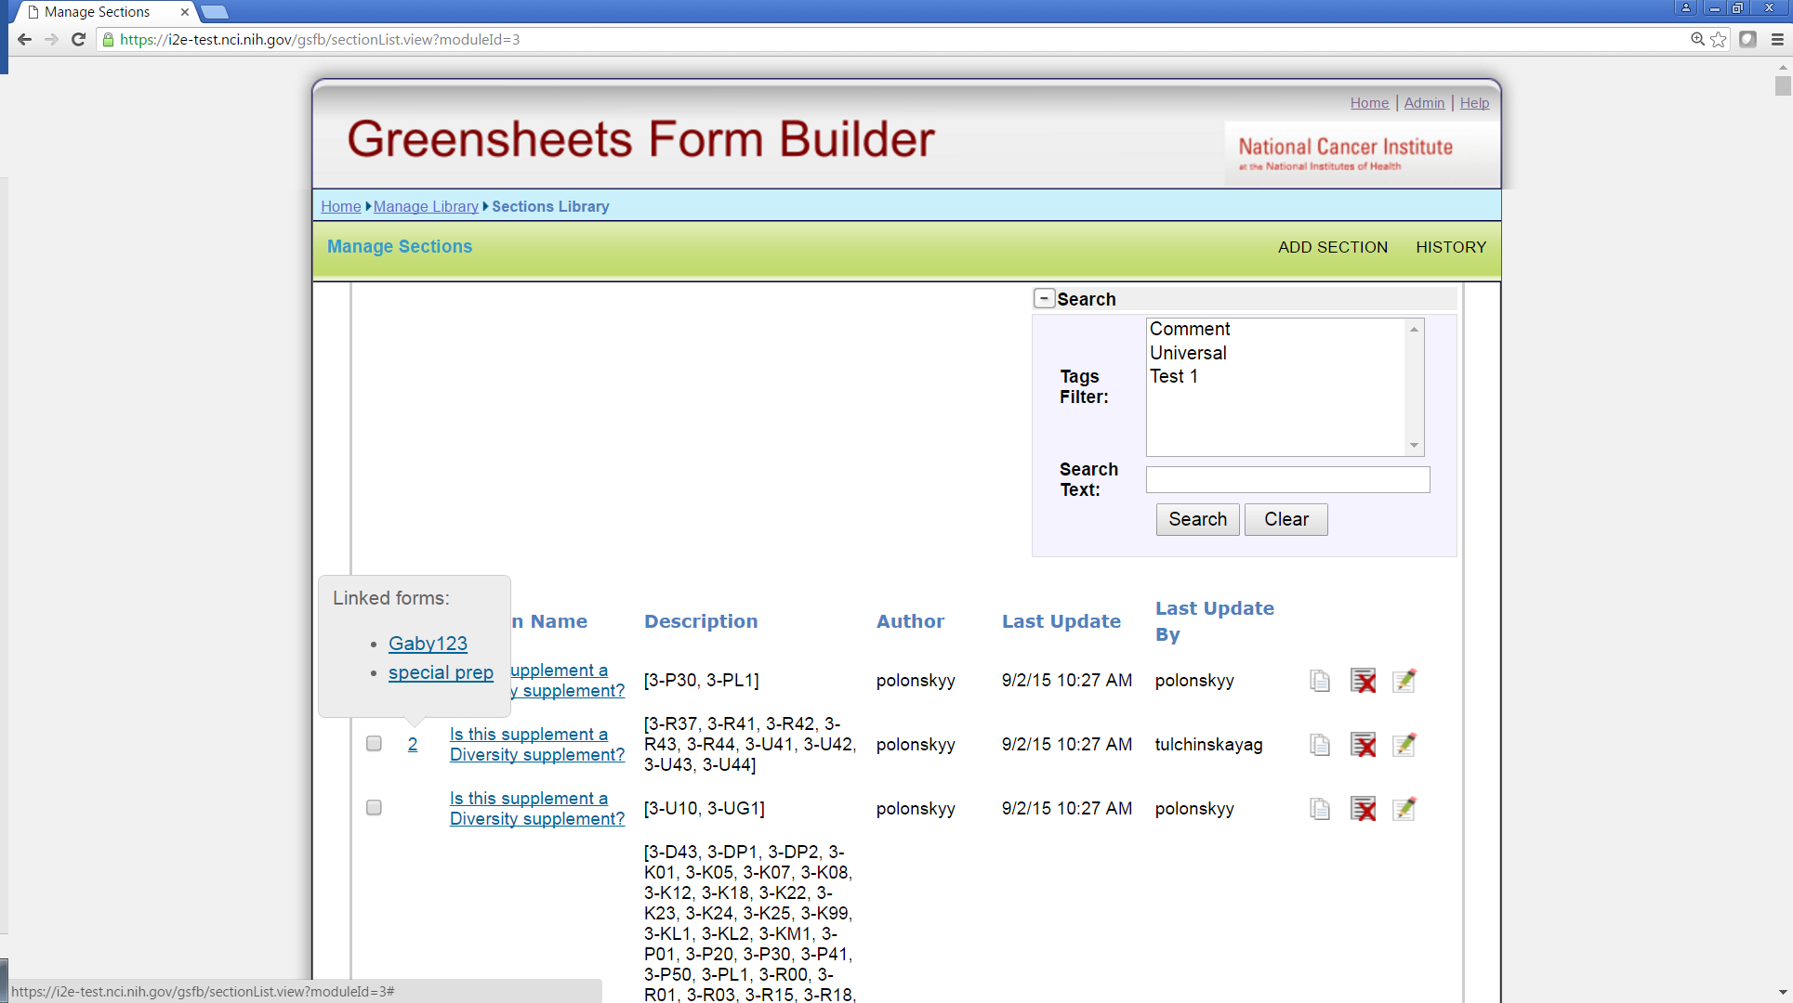

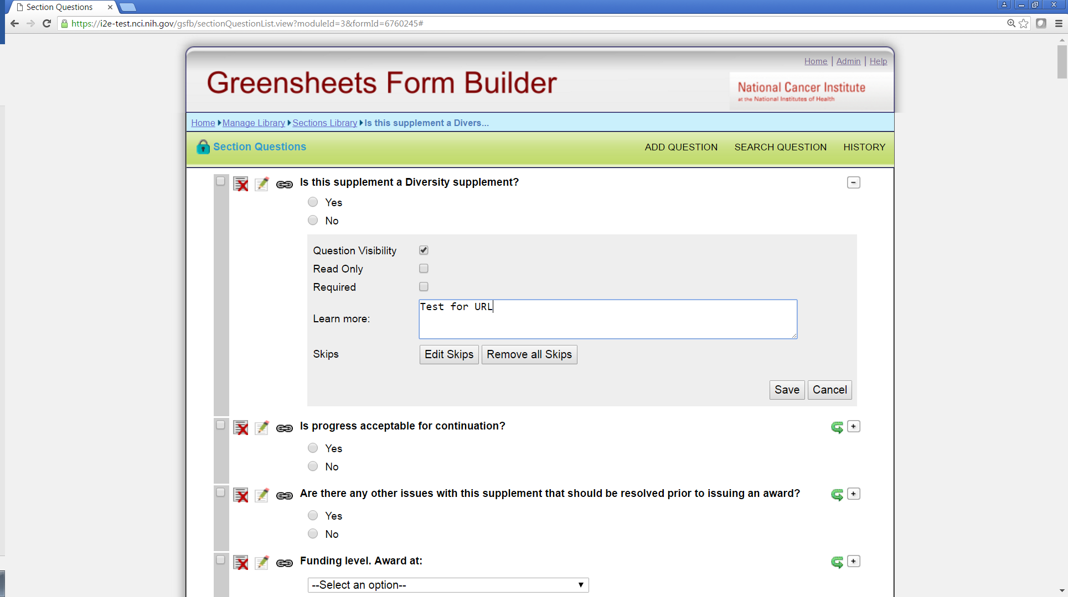

Or

* 1. **Per question in the question library:** Do users want to open the question in the question library, have information about all forms/modules/type/mechs where this question is used => add/modify hyperlink for the question => it will update all forms => redeploy all affected forms/modules? *In this case we will need add editor to the “learn more’ field for question in the question library, provide better indication of usage on this* ***question*** *page (e.g. extend History functionality), and add extra validations*

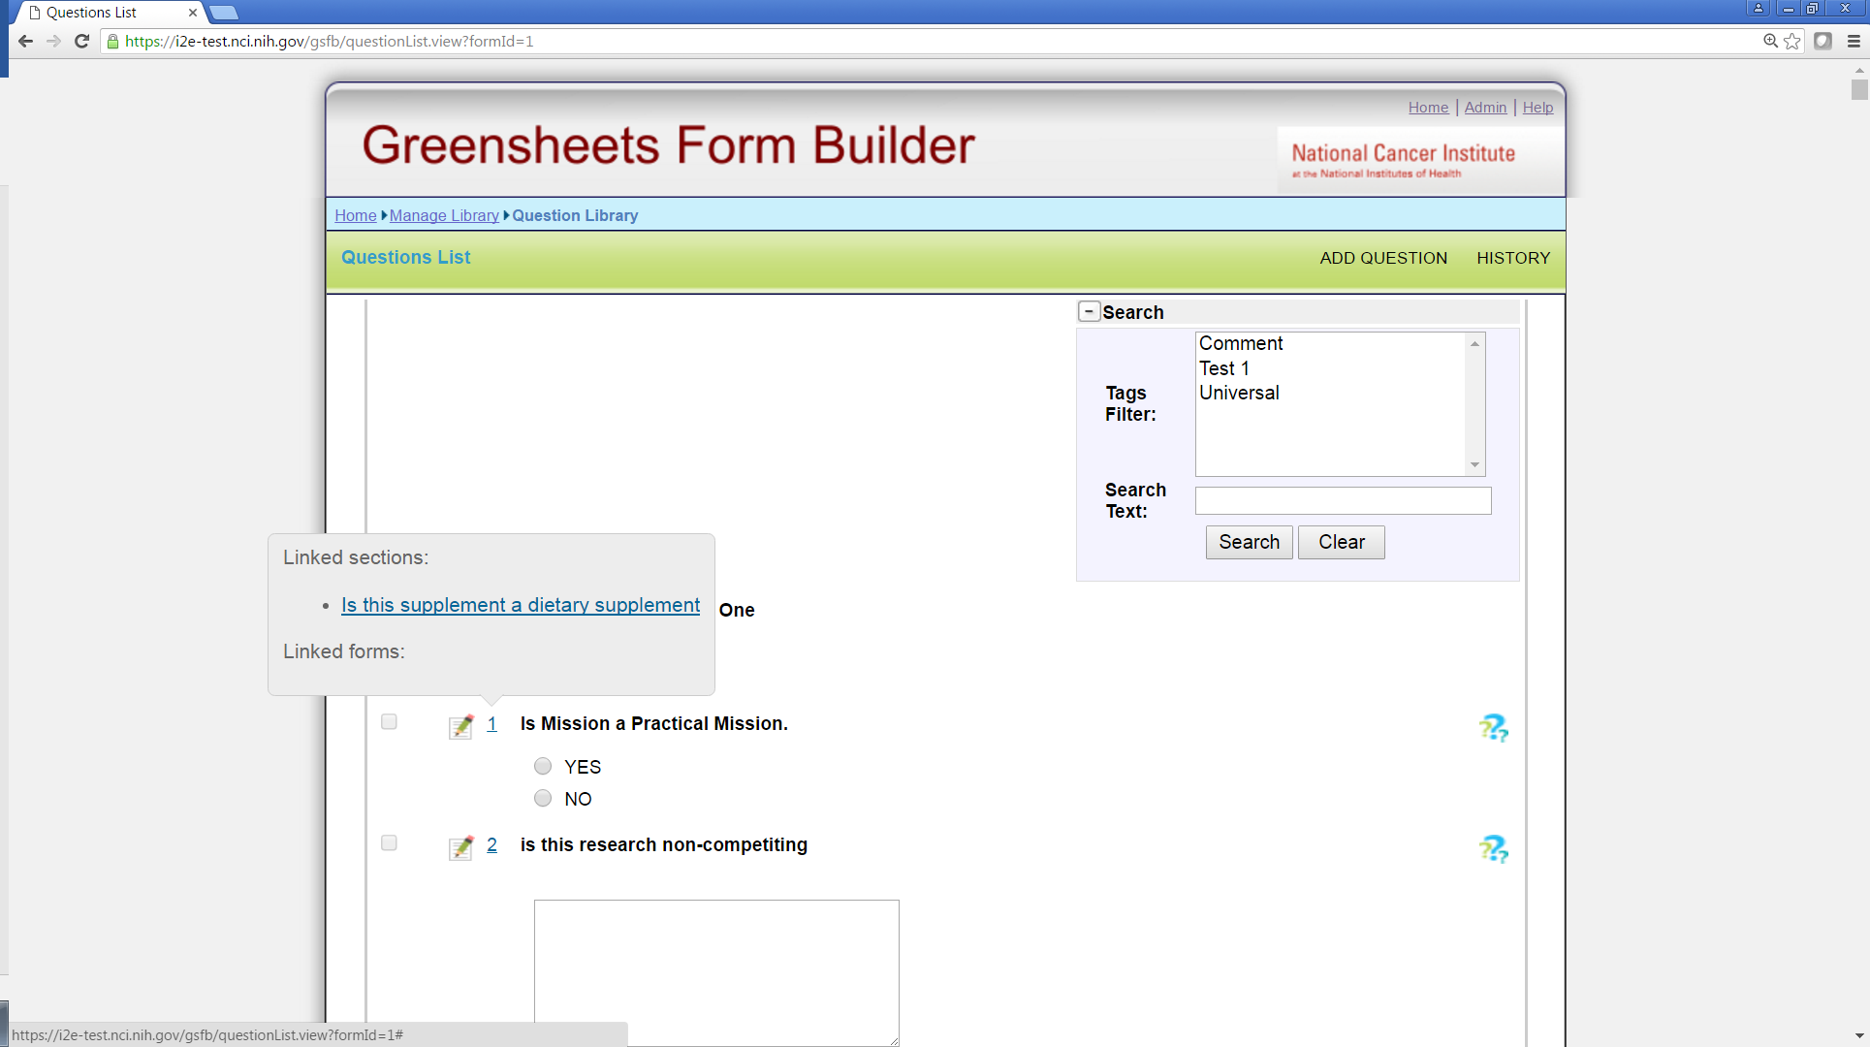



## **Creation of the Revision form in FB and promotion of the Revision module**

This proposal is based on the requirements:

* Only one revision form is needed for all type/mechs
* Revision form will be used by Specialist only

**Proposed workflow**

**OGA user** will (see mockups below):

* create a new module in FB (user can call it “Revision module”, but this is “as-is” functionality, no changes)
* create a form (user can call it “Revision form”, but this is “as-is” functionality, no changes)
* The only change for a user => add new **category of revision type, select ALL type/ALL mech combination to a form, and add Revision form to this category**
* add Revision form to Revision module (no changes)
* deploy the module as usual

**Changes to create a category process**

The system will allow to select ALL types and mechanisms while creating a category.

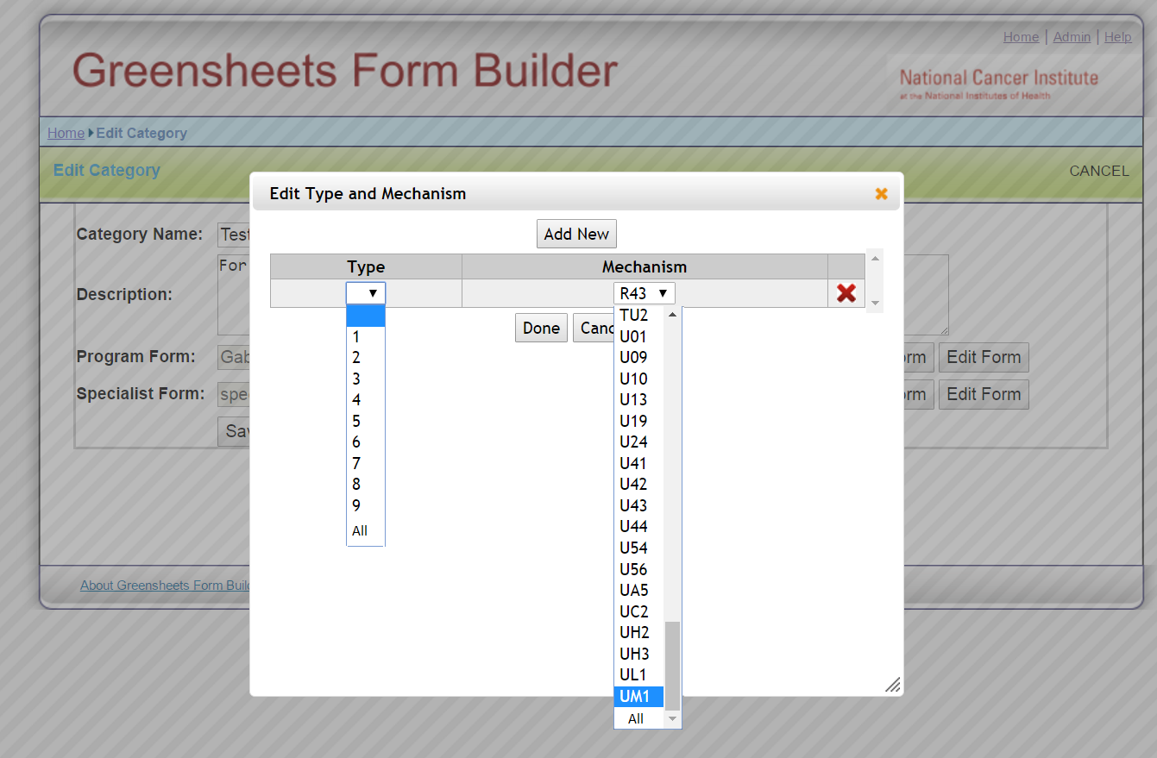

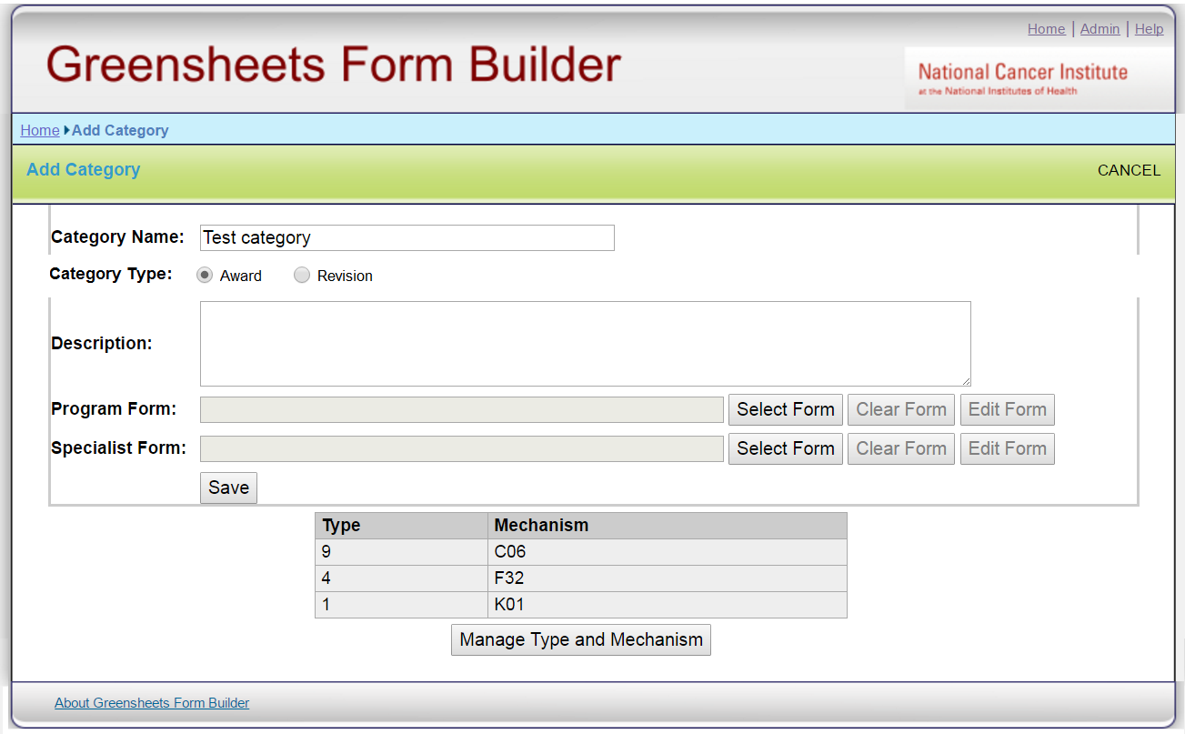

When OGA user adds a category, s/he may choose a category type (Award or Revision)

On the screen category type will be defaulted to ‘Award’ (OGA mentioned that after Revision form is created and deployed, it will never change).

* If ‘Award’ type is chosen, the process is as usual
* If “Revision” type is chosen:
* The screen will allow adding only Revision form
* User will select ALL types/mechanisms (no validation for ALL/ALL combination, it will be responsibility of the user, it will allow more flexibility in the future)

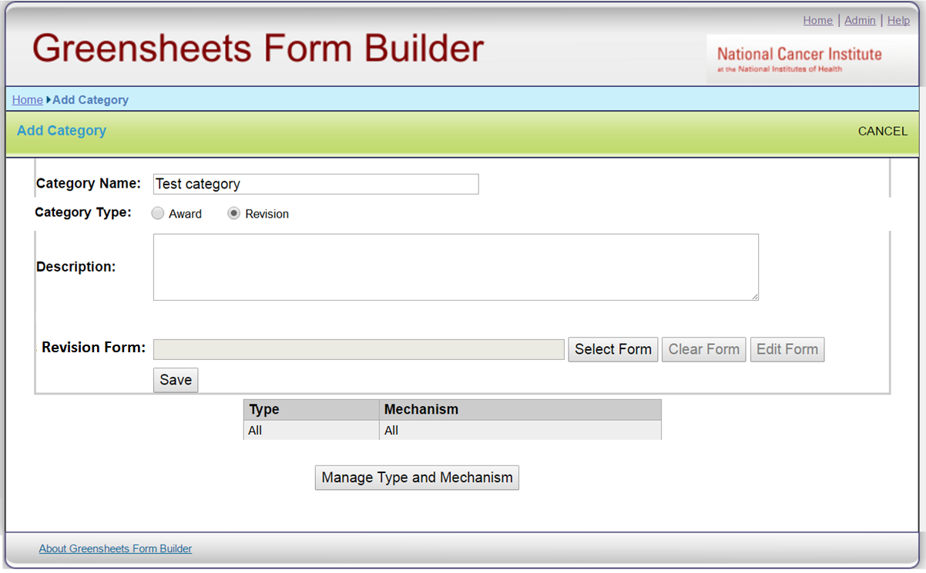

**C**ategory type will become read-only when editing existing category.

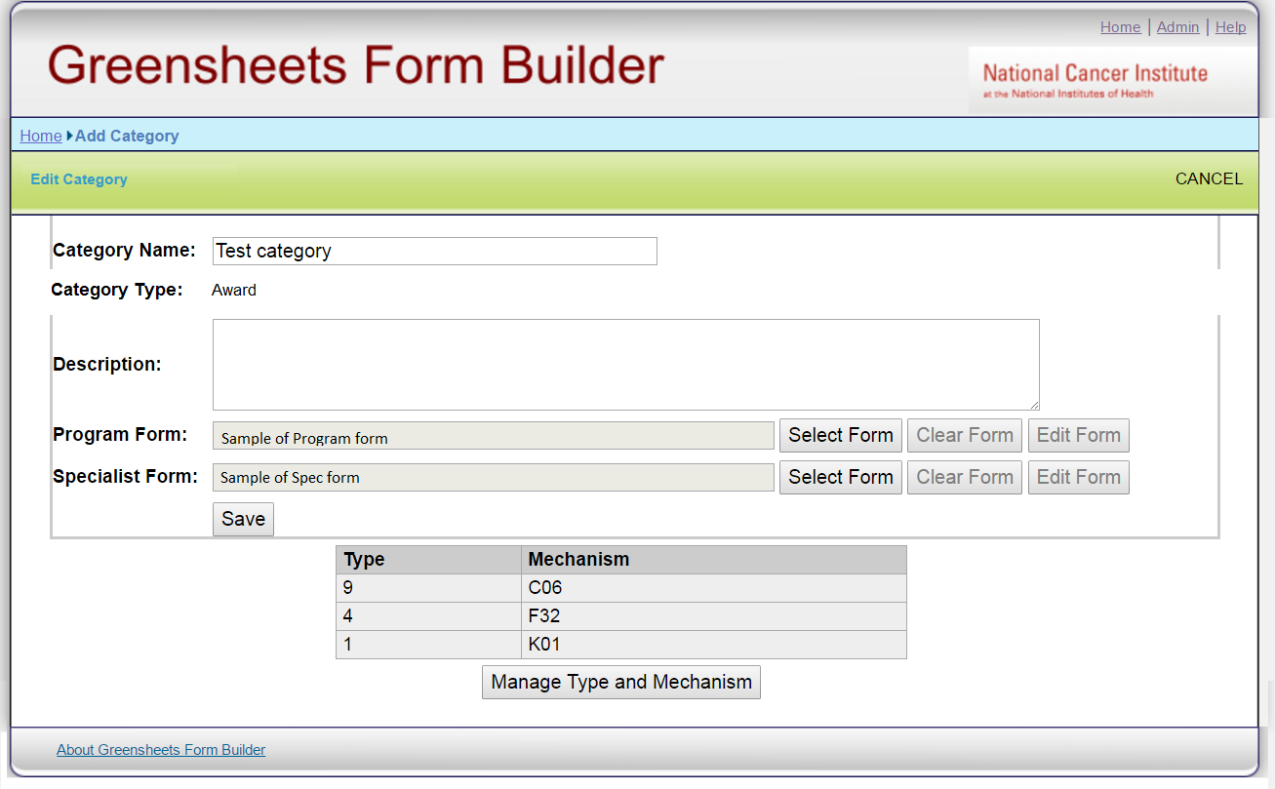

## **Issues related to navigation:**

* **Navigation between a specific greensheet and Grants List screen**

**Questions**:

1. Currently a user can navigate to a hit list screen only via Workbench. Majority of SPECIALISTS navigate to a specific greensheet via eGrants or (in the future) via GPMATS. Is there any value in having hit list screen at all or should we get rid of it? Are there any other categories of people from OGA who need to see the whole hit list? If yes, what is their landing page?
   1. If we need to get rid of grants list screen for specialists, what a specialist will see if s/he navigates from Workbench? Do you see GPMATS criteria to change in any way
   2. If we need to keep a grants list screen for Specialists, we need to resume postponed discussion about display of revision greensheets on the hit list. From the meeting minutes about revised awards: “*OGA will evaluate the need to display revision awards on the hit list screen, maybe only AWARD actions will be displayed*.”

**Question:** Should Revision greensheet be displayed on grants list (see mockup below)?

* + - If yes (display Revision greensheets on a hit list), should greensheets record display any additional information about revision action (e.g. OGA award release date)?
    - If no (do NOT display Revision greensheets on a hit list), do we need any changes to the screen at all (e.g. somehow indicate that revisions exist for certain grants)?

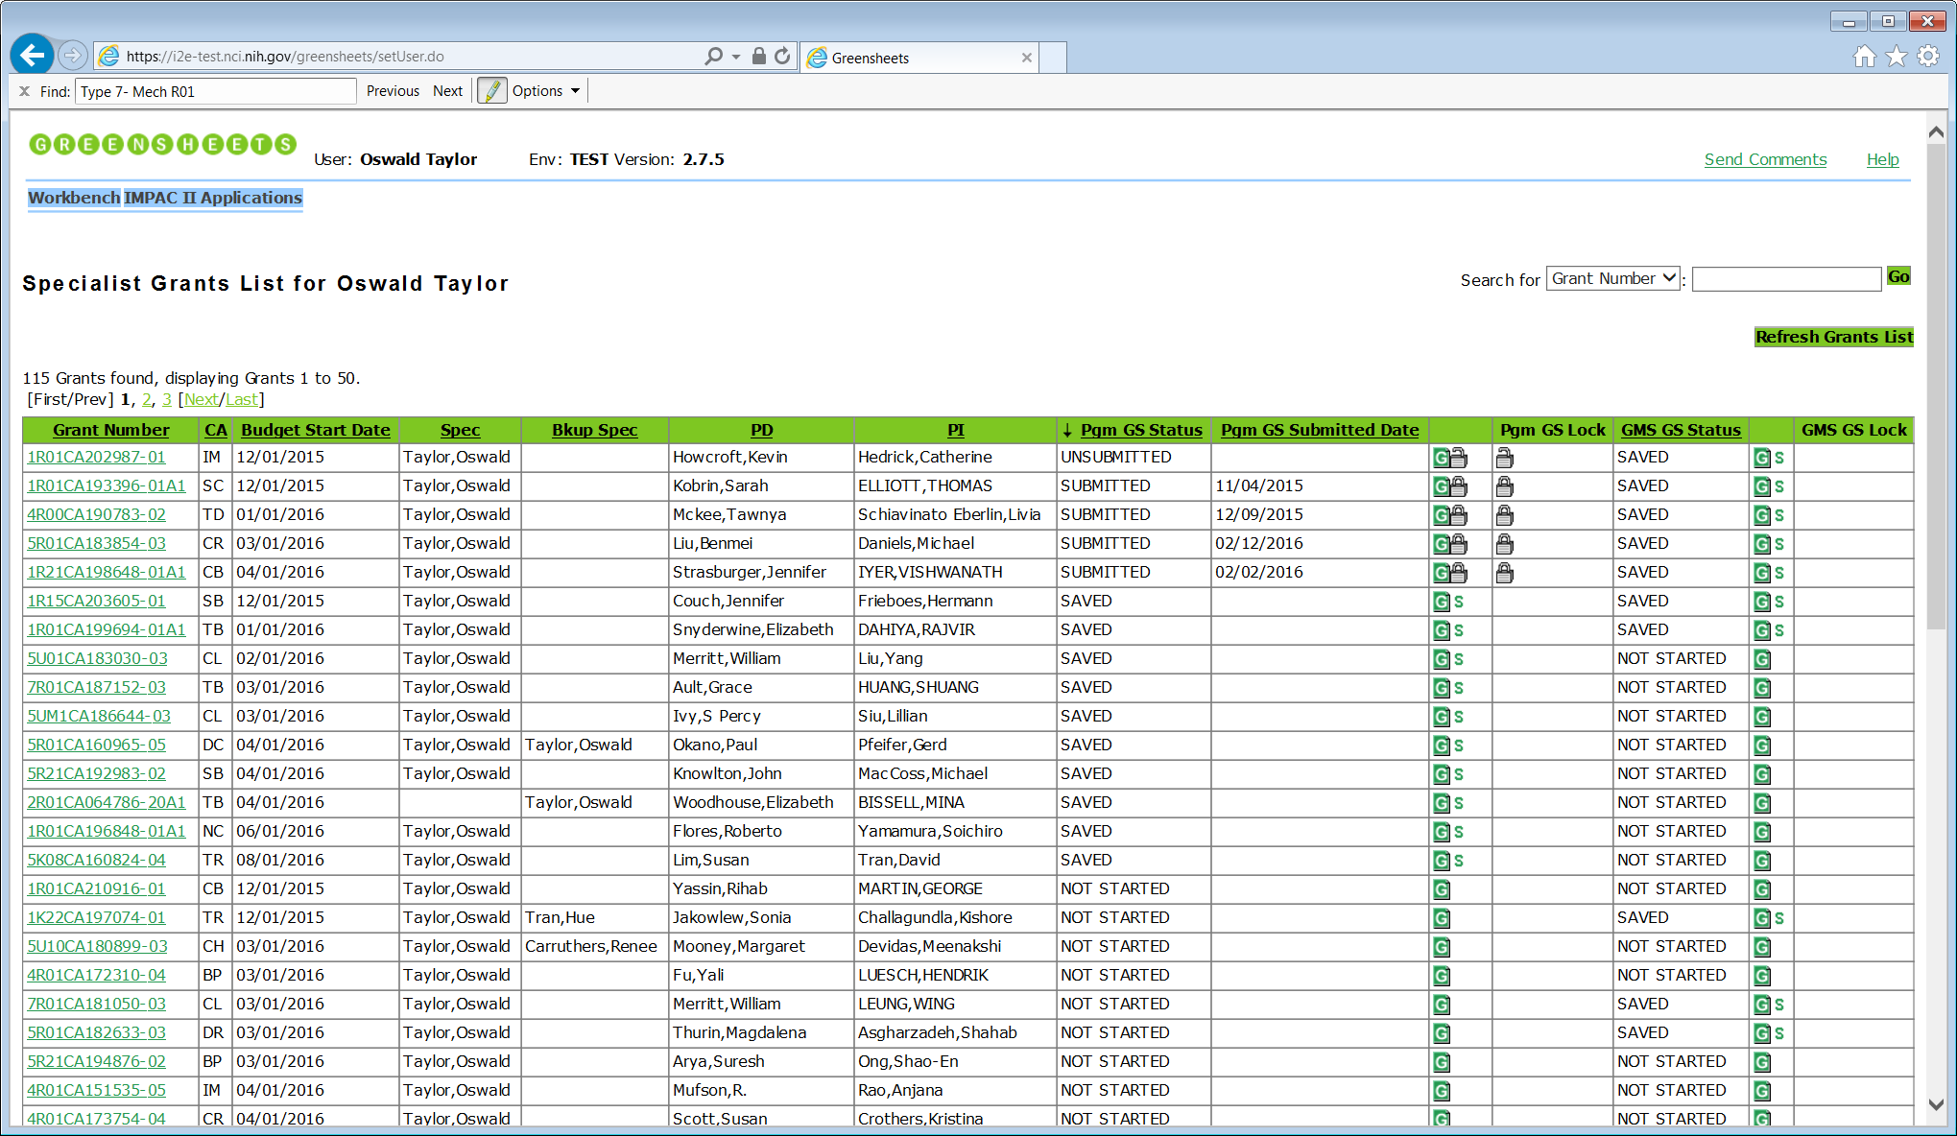

|  |  |  |  |  |  |  |  |  |  |  |  |  |  |  |  |
| --- | --- | --- | --- | --- | --- | --- | --- | --- | --- | --- | --- | --- | --- | --- | --- |
| **Grant Number** | **CA** | **Budget Start Date** | **Spec** | **Bkup Spec** | **PD** | **PI** | **GPMATS Action Type** | **OGA Award Release date** | **Pgm GS Status** | **Pgm GS Submitted date** |  | **Pgm GS Lock** | **GMS GS Status** |  | **GMS GS Lock** |
| 1R01CA202987-01 | IM | 12/01/2016 | Taylor, Oswald | Clark, Patty | Liu, Grace | Tran, David | Award | 5/29/2015 | FROZEN | 11/04/2016 |  |  | FROZEN |  |  |
| Revision/ Term change | 2/03/2016 |  |  |  |  | FROZEN |  |  |
| Revision/ Co-fund |  |  |  |  |  | SAVED |  |  |
| 5R01CA123456-04 | CE | 12/01/2016 | Clark, Patty | Perry, Carol | Hubbard, Leah | Wu, Tzyy | Award |  | SUBMITTED | 11/04/2016 |  |  | SAVED |  |  |
| 5R01CA077476-03A1 | CB | 12/01/2016 | Clark, Patty |  | Hubbard, Leah | Woo, Tong | Award | 2/03/2016 | FROZEN | 11/04/2016 |  |  | FROZEN |  |  |
| Revision/ Co-fund |  |  |  |  |  | SAVED |  |  |